Diagrama de secuencia de *“BuyOffer(g)”:*

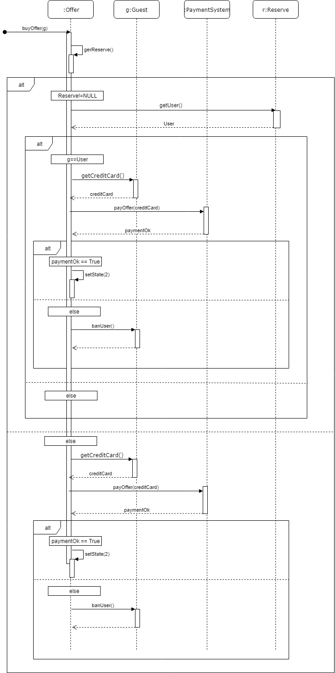

Diagrama de secuencia de *“SearchOffer(z)”*:

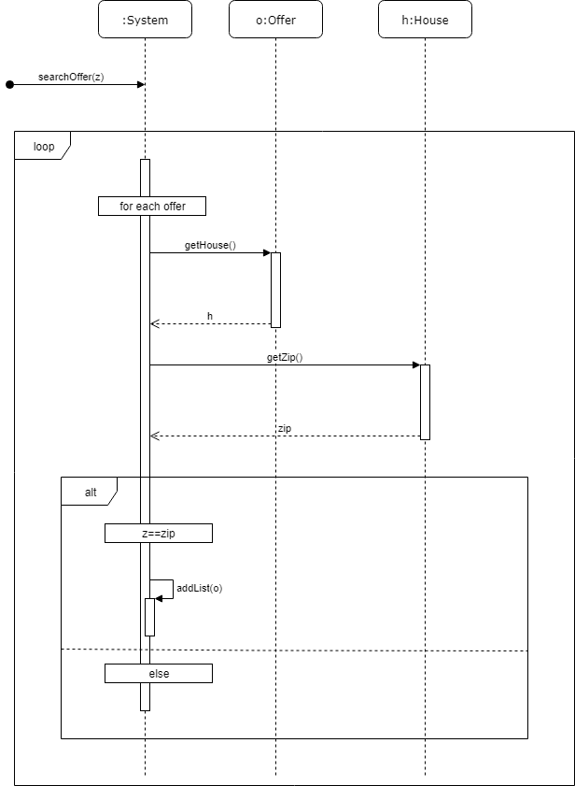

Comments about buyOffer(g)

In this diagram we have represented the method buyOffer, which is given the Guest g as a parameter.

The first thing we need to do is check if the offer is already reserved.

* If it is, we get the user that has reserved it and check if it is the same as the one trying to buy the offer.
  + If it is, we procced to the payment. We first get the credit card of the user and give it to the PaymenySystem which will return the Boolean paymentOk that says if the payment was successfully done.
    - If paymentOk is TRUE, we change the state of the offer to ‘2’ (Which is the state that we have assigned as reserved)
    - If it’s not, we ban the user changing its credit card. (We are not going to describe this method because it’s not the chosen one)
  + If it’s not the same user, the function needs to end because he can’t buy that offer.
* If it’s not reserved we directly proceed to the payment, the same way as we did before.

Comments about searchOffer(z)

In this diagram is represented the method searchOffer(z), which is given the zip code as a parameter.

This method mainly has a loop that goes through all the offers and gets their houses and, from those houses, the zips. Then it checks if that zip is the same as the one given as a parameter. If it is, what we have done is add that offer to a list, which will be the one that is finally returned as the result of the search.